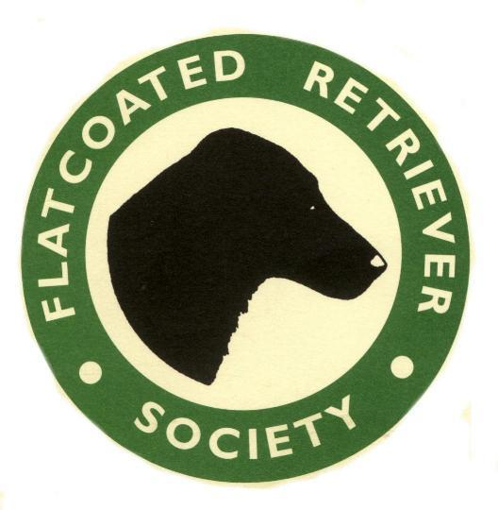THE FLATCOATED RETRIEVER SOCIETY

Affiliated to the Kennel Club, the Countryside Alliance, the B.A.S.C. the N.G.O. and the International Gundog League
www.flatcoated-retriever-society.org

Field Trial Secretary
Helen Ford
Falkedon
Spreyton
Devon
EX17 5EF
Email fcrs@falkedon.net

Working results for 2021/2022 SEASON:

Name of Dog:
Sex: |  |  | DoB:
Name of Owner:
Address:
Name of Handler:
Type of Stake or WT | Society |  |  |  |  | Date |  | Place |  |  | Judges
FT

